**Bug on Page ‘www.bonify.de​’:**

**Issues 10:**

1: On ‘<https://www.bonify.de/agb>’ Page, typo error marked in Red (Extra Closing Braces).

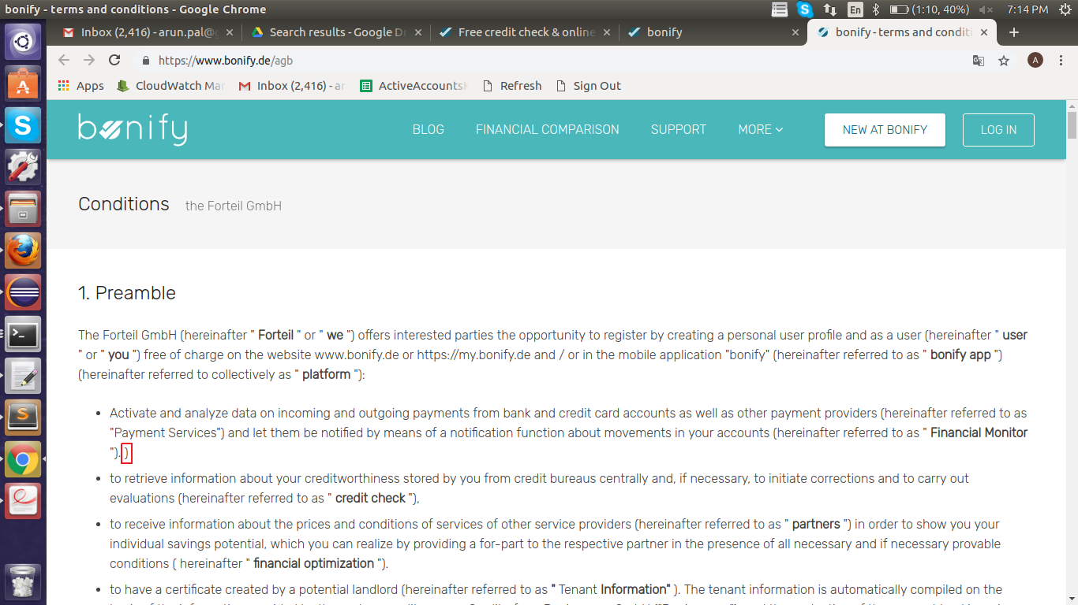

Steps to REproduce:

1: Go to ‘<https://www.bonify.de/agb>’ page and convert content from DE to EN.

2: Observe the extra closing braces for ‘... " Financial Monitor "). )’.

**Expected Result:** Please remove extra closing braces.

**Actual Result:** Observer extra closing braces in ‘... " Financial Monitor "). )’.

**Browser:** Chrome (Version 70)

**OS:** Ubuntu (16)

**Priority:** P4

**Assign To :** Developer.